Technical Offer

Customer: Gates India
Title: Manufacturing Execution System

To,

Gates India

Kind Attention: Mr.

Contact: Sanjay Goyal
Email ID: sanjay.goyal@smartcontrols.in
Phone: +91 9755945046

Dear Sir,

Subject: Barcoding System for RMS to Mixer traceability

Please find annexed our technical offer based on the discussion during the plant visit.

In case you need any further clarifications, please feel free to call us at any time convenient to you.

Thanking you and always assuring you of our best attention.

Yours truly,
Smart Controls India Limited

Sanjay Goyal

Table of Contents
1 Terms and Abbreviations 3
2 Basis Of Offer 5
2.1 Revision History 5
3 Scope Of Work 5
3.1 Overview 5
3.2 Purpose & Objectives 5
3.3 Scope and Limitation 5
3.3.1 IT – Infra Requirement 5
3.3.2 Team Required 6
3.3.3 Scope Covered 6
Common: Hardware 7
3.3.4 Area/Machine hardware Matrix 16
3.4 Timeline 16
4 Project Key Success Factors 17
4.1 Project Assumptions 17
4.2 Customer Support 17
4.3 Exclusions 17
5 Change Request Procedure 18
5.1 Change Request Implementation Stages: 20
6 Acceptance Procedures 21
6.1 Notification of Deliverable Available Date 21
6.2 User Acceptance Tests 21
6.3 Inspection and Acceptance of Deliverables by Customer 21
7 Commercial 22
7.1 Price Schedule 22
7.2 Terms Of Payment 22
8 Ownership of Deliverables 23
9 Terms and Conditions 24

Terms and Abbreviations
Terms | Definition
SC/SCIL | Smart Controls India Ltd
CUSTOMER | Gates India
END USER | Gates India
MOM | Manufacturing Operation Management
ERP | Enterprise Resource Planning
MES | Manufacturing Execution System
SPOC | Single Point of Contact
WSUS | Windows Server Update Services

RACI Terms
R | Responsible: | Team who performs the activity.
A | Accountable: | Team who should answer for the success/failure/quality and timeliness of action.
C | Consulted: | Team who must be consulted before the action is performed.
I | Informed: | Team who must be informed after the action is performed.

Basis Of Offer

Revision History
Revision 0
As per the discussion and document.

Scope Of Work

Overview
The Barcoding System for RMS to Mixer Traceability ensures error-free material feeding, accurate material consumption tracking, and seamless traceability through QR-coded lot identification. It enables real-time monitoring, production reporting, and data-driven decision-making, enhancing efficiency and compliance in manufacturing operations.

Purpose & Objectives
The purpose of this project is to design, develop, and implement a system that:
- Ensures poka-yoke in material feeding stations.
- Calculates material consumption based on the defined Bill of Material (BOM).
- Generates a QR code label for each produced lot.
- Enables tracking and traceability at all levels of material flow.
- Generates production/other reports for monitoring and analysis.

Scope and Limitation

IT – Infra Requirement

VM | vCPU (2.4 GHZ or Above) | RAM (GB) | Hard Disk (GB SSD)
RMS - Mixer App- Production | 8 | 64 | C:256, D: 512
Date Base - Production | 12 | 128 | C:256, D: 2048
App + DB - QA | 6 | 64 | C:256, D: 512
10% Additional

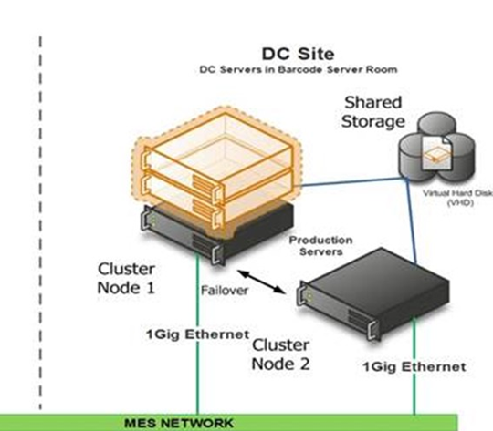

Team Required
Customer:
PLC Programmer – (For all the necessary inputs required)
IT Engineer – (For infra readiness and related support)
SCIL:
Project Manager/ SME – (For internal and external co-ordination, SME)
Developer – (Developing application)
Commissioning Engineer – (Deployment and configuration)
QA – (For testing the applications)

Scope Covered
The proposed system covered Following equipment’s.
List of Equipment
S. No | Area | No of Machines | Description
1 | RMS Booking | 1 | Raw material storage, receipt, and placement in the storage area.
2 | RMS Issue | 2 | Issue material to shop floor from raw material storage.
3 | Carbon Silica & Other | 12 | 12 feeders feed material.
4 | Oil | 10 | Oil stations for specific materials.
5 | Auto Chemical | 2 | Approx. 50 bins for feeding in each small chemical.
6 | Bale Cutter | 2 | Cutting polymer into separate lots.
7 | Mixer Feeding | 2 | Operator feeds polymer/compound based on recipe.
8 | Mixer Batchoff | 2 | Load batch output onto skid.
 | Total | 33

Common: Hardware
- Refer to the area/machine hardware matrix for understanding the considered hardware for machine.
Common: Modules (Service)
Item – BOM management
A centralized item management system designed to efficiently manage items, Bill of Materials (BOM), and specifications. The primary goal of this system is to streamline data handling for consumption calculations, validation processes, and other relevant purposes. It is important to note that this system does not involve any synchronization of data with machines.
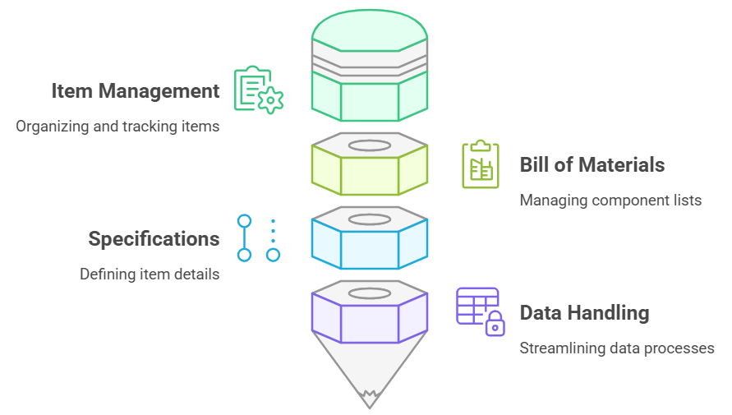
Material Traceability
- Implementing barcode and QR code-based tracking for all materials.
- Ensuring real-time linkage of input materials to produced products.
- Automating validation & Interlocking based on the available machine interfac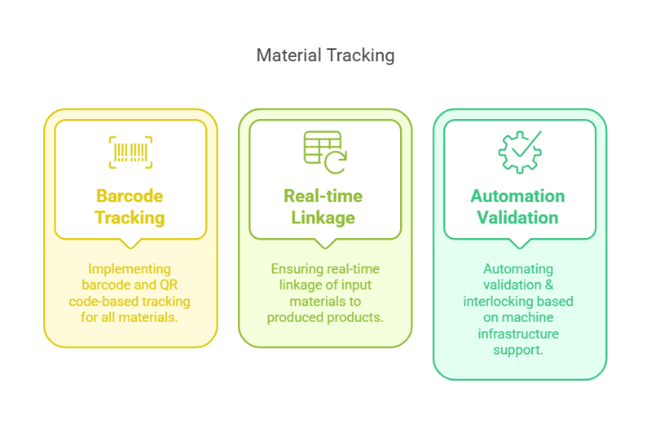
Material Validation
- Integrating QR code-based validation to prevent incorrect material usage.
- Validation cover, Item, FIFO & Ageing. FIFO logic will follow the defined window to validate.
- Interlocking production systems with validation.
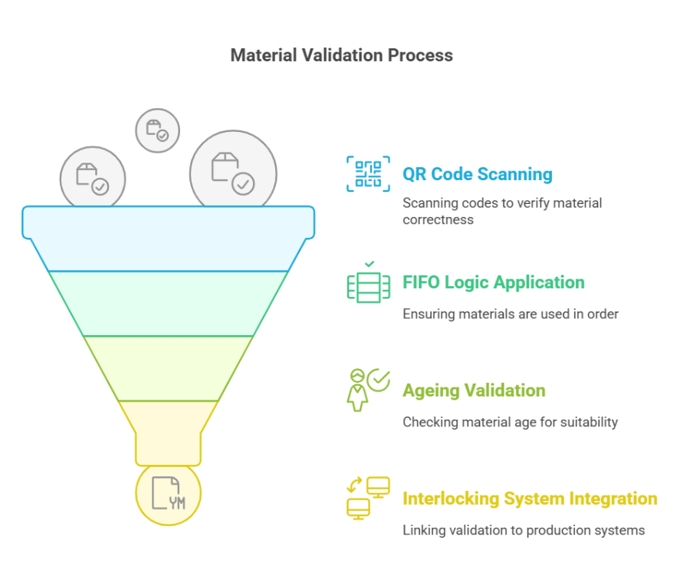
Data Integration & System Communication
- Enabling real-time data exchange between MES, ERP & PLC subject to interface availability at PLC end and ERP support.
- IT – OT network must be isolated and communicated with the MES server
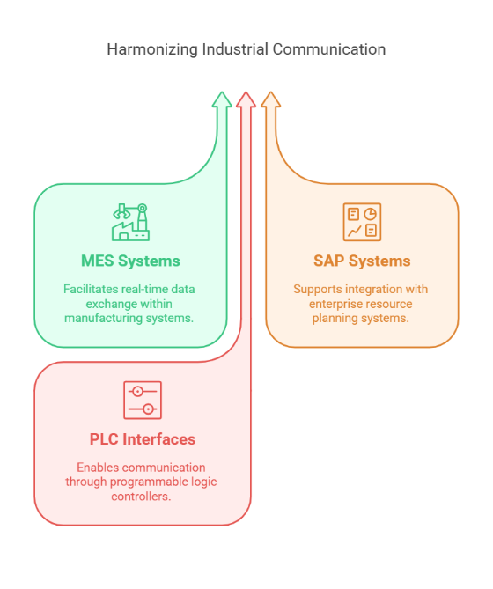
Inventory & Material Handling Efficiency
- Tracking inventory movement using QR codes and location-based storage subject to marked location infrastructures available.
- Equipping Material Handling Equipment (MHE) with metallic QR codes for tracking
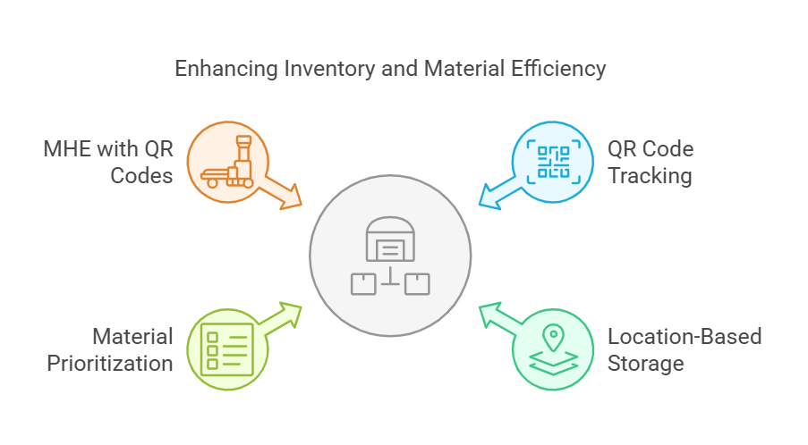

Operator & Access Control
- Implementing individual operator logins for production and booking stations.
- One machine one operator considered
- Enabling role-based access to critical processes and approval workflows.
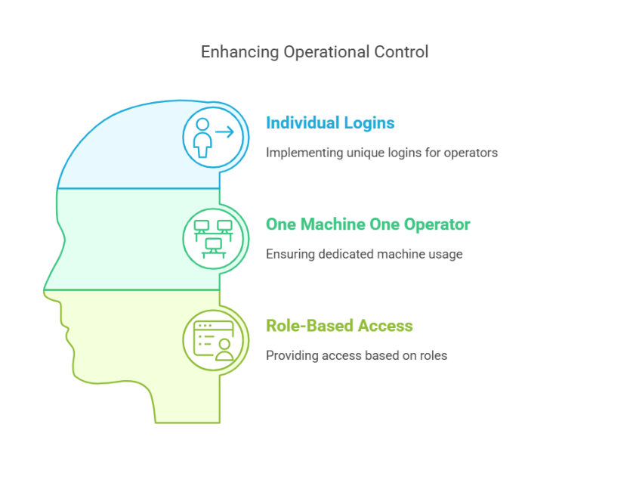
System Integration Considerations
- Barcode & QR Code System: Will be used for material tracking across all production stages
- PLC: To keep IT – OT isolation. Unique IP addresses will be assigned for effective MES communication.
- ERP/MES Data Exchange: Ensuring near real-time data synchronization at defined intervals.
- MHE Tracking: Material Handling Equipment will be equipped with metallic QR codes for precise traceability. This is subject to MHE supports. Not all MHE will have this

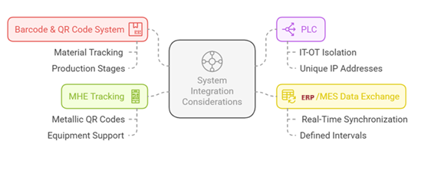

RMS: Booking & Issue
- Deployment & Configuration: Implementation of the module at plant, ensuring seamless setup and configuration.
- Functional Scope Booking:
  - MMR booked in Oracle ERP system.
  - MES fetches data from ERP and splits material quantity into lots.
  - QR code and sticker printed for each lot.
  - Materials placed in dedicated locations by type.
  - Inventory visible by location, material, aging, and vendor.
- Functional Scope Issue:
  - Issue slip generated.
  - Based on issue slip, user issues the material.
  - Validate material, quantity, aging, and FIFO.
- ERP Integration: Any required changes or modifications at the ERP level will be under the customer scope.
- Hardware considered: Refer to the Area/machine hardware matrix
Bale cutter
Deployment & Configuration:
MES module will be deployed and configured at the Bale Cutter station to manage and monitor lot-level operations, enabling seamless data flow and traceability.
Functional Scope – Lot Mixing Management:
- MES will support receipt and identification of multiple raw material lots at the bale cutting stage.
- Operator will initiate the cutting process, where materials from different lots can be mixed.
- Upon completion, MES will auto-generate a unique Final Lot Number for the mixed material.
- The Final Lot Number will be logically and digitally linked to all contributing lots within the MES.
- This linkage enables complete backward traceability, essential for quality assurance, root cause analysis, and regulatory compliance.
- MES will maintain a material genealogy record, accessible for reporting and audit purposes.
ERP Integration:
MES will read material master from ERP where applicable. Any ERP-side changes or customizations shall remain in customer scope.
Hardware Considered:
Refer to the Area/Machine Hardware Matrix.

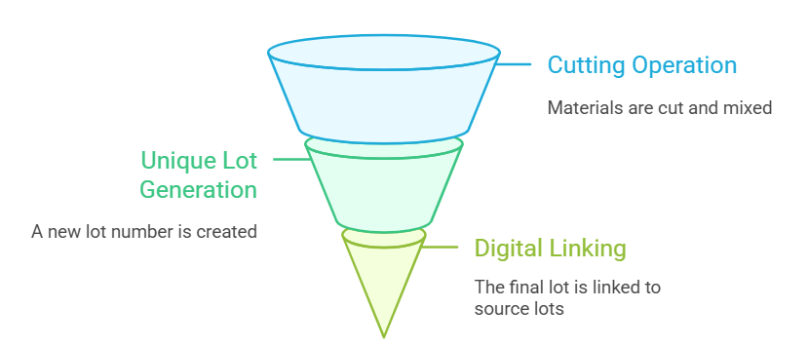
Carbon, Silica & Other (12 feeder)
Deployment & Configuration:
MES module will be deployed and configured at all 12 feeders handling Carbon, Silica, and other materials to monitor feeding operations, enforce validations, and ensure traceability.
Functional Scope – Material Feeding & Validation:
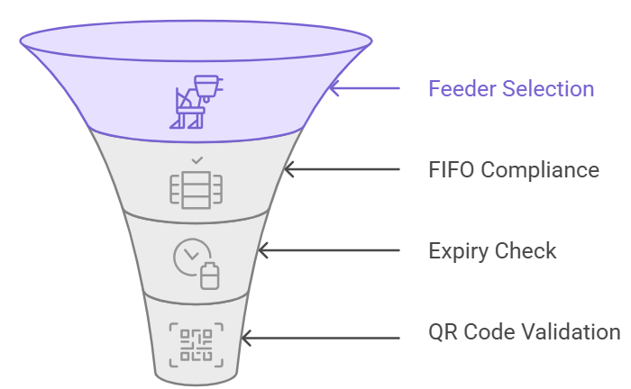
- Each feeder will be pre-defined with its respective allowed material codes.
- As per the daily plan, bags will be scanned and fed into the respective feeders.
- MES will track every feeding transaction, capturing details such as feeder ID, material code, lot number, time, and user.
- The HMI will display, for each feeder, the list of allowed materials as well as the materials currently loaded, enabling operators to easily verify and ensure correct feeding
- The MES scanner will guide users during material feeding, while the stack light will provide immediate visual feedback — indicating correct or incorrect material scans.
- Feeding validations performed by MES include:
- Correct Feeder as per mapping
- FIFO Compliance based on lot aging
- Rejection of expired or blocked lots
- Feeders are tagged with metal QR codes which are scanned to ensure accurate feeder identification and validation before feeding.
Traceability & Reporting:
- MES maintains a detailed traceability log, linking material lots to the corresponding feeder and time of use.
- This supports material genealogy, quality audits, and production root cause analysis.
ERP Integration:
MES will use ERP master data for material and lot information. Any modifications required at ERP level (e.g., additional lot attributes) will be in customer scope.
Hardware Considered:
Refer to the Area/Machine Hardware Matrix.

OIL
Deployment & Configuration:
MES module will be deployed and configured to manage and track oil feeding operations across designated feeders, ensuring validation, control, and traceability.
Functional Scope – Oil Feeding & Validation:
- Each oil feeder is pre-configured in MES with the list of allowed oil types.
- MES will track and record all oil feeding activities, capturing details such as feeder ID, oil type, lot number, operator, and timestamp.
- The system will perform validations before allowing feeding:
▪ Correct Feeder Assignment based on oil type
▪ FIFO Compliance to ensure older lots are consumed first
▪ Blocking of Expired Materials to prevent usage
- Feeders are tagged with metal QR codes, scanned before each feeding for secure identification and validation.
Feeder Control Integration:
Oil feeding doors are automatically controlled by the system. Doors will only open after all MES validations are successfully passed, ensuring process integrity and compliance.
Traceability & Reporting:
MES will maintain detailed records of oil usage by feeder, lot, and batch to support material genealogy and audit requirements.
ERP Integration:
MES will fetch master data from ERP. Any ERP-side configuration or data alignment will be under customer scope.
Hardware Considered:
Refer to the Area/Machine Hardware Matrix. Hardware related to controlling the door will be in customer scope.
Auto Chemical
Deployment & Configuration:
MES module will be implemented and configured to integrate with the existing SCADA/PLC infrastructure for automated chemical feeding operations and ensure traceability, control, and production linkage.
Functional Scope – Feeding Control & Traceability:
- WinCC SCADA logs both bag production and chemical consumption.
- MES receives signals from PLC/SCADA on planned, running, and completed production batches.
- Each trolley and feeder are tagged with a unique QR code to ensure secure material tracking and traceability.
- HMI displays the list of allowed materials and currently loaded material for each feeder.
- Feeder bin remains locked if a wrong material is scanned, preventing incorrect loading.
- MES provides a dedicated HMI display to show trolley status, bin lookup, and production history for full visibility.
Production Linkage:
MES links each produced bag to the respective input materials, based on real-time SCADA consumption data, ensuring accurate batch-level traceability and genealogy.
System Controls & Alarms:
- Built-in interlocks and alarm mechanisms prevent feeding errors, wrong material usage, and unauthorized access.
- All mismatches and critical events are logged for audit purposes.
ERP Integration:
MES will utilize ERP master data (material codes). Any ERP modifications required will remain under customer scope.
Hardware Considered:
Refer to the Area/Machine Hardware Matrix for QR scanners, HMIs, label printers, and any other hardware.
Mixer: Feeding
Deployment & Configuration:
MES module will be deployed and integrated with the mixer PLC and SCADA to monitor and guide the feeding process, ensuring accurate data capture, validation, and traceability.
Functional Scope – Material Feeding & Validation:
- Polymers and chemical materials are fed into the mixer after scanning their lot codes using Wi-Fi barcode scanners.
- Carbon and other bulk materials are consumed directly from bins, without individual lot-level scanning.
- MES will interface with the mixer PLC, which provides real-time tags for Plan ID, Recipe ID, Material Code, and Batch No.
- HF Advice SCADA is in use but lacks OEM support; MES will rely on PLC tags and available SCADA signals if available.
- As actual consumption is not captured in SCADA, MES will perform material consumption logging based on BOM-defined quantities.
- Operator HMIs will display recipe details and guide feeding operations with clear instructions and status updates.
Traceability & Logging:
- MES will maintain lot-wise traceability for scanned materials and associate them with the respective batches produced.
- Feeding events, lot usage, operator actions, and timestamps will be logged and available for reporting and audit.
ERP Integration:
MES will retrieve material master, plan, and lot data from ERP. Any changes to ERP structure or logic will remain in customer scope.
Hardware Considered:
Refer to the Area/Machine Hardware Matrix for considered hardware.
Mixer: Batch off
Deployment & Configuration:
MES module will be implemented in the Mixer Batch Off area to track, record, and validate batch transfer activities, ensuring accurate traceability and operational control.
Functional Scope – Batch Off Monitoring & Traceability:
- MES will monitor the start and stop of each batch off operation in real time via interface with the control system or operator inputs.
- Upon batch off completion, the operator will enter the number of batches taken out through the MES interface or HMI.
- MES is already integrated with mixer operations and applies FIFO logic to track and associate dumped batches with production plans.
- MES will generate and print stickers for each batch off event, including relevant details such as Batch No, Recipe, Timestamp, and Lot traceability, ensuring accurate labelling and production linkage.
Traceability & Recordkeeping:
- All batch off activities will be logged by MES and linked to the corresponding mixer batch for end-to-end material and batch genealogy.
- This ensures full visibility during downstream processes and supports audit, compliance, and quality reporting.
ERP Integration:
MES will use ERP plan and material data to support production alignment. Any necessary ERP-side changes (e.g., batch posting or integration logic) will be under customer scope.
Hardware Considered:
Refer to the Area/Machine Hardware Matrix. Requirements include MES terminals/HMIs and label printers at the Batch Off station.

Area/Machine hardware Matrix
S. No | Area | No of Machines | MES Hardware
 |  |  | PC | HMI | BT Scanner | Wi-Fi Mobile Scanner | Stack Light | Printer
1 | RMS Booking | 1 | 1 |  |  |  |  | 2
2 | RMS Issue | 2 |  |  |  | 2
3 | Carbon Silica & Other | 12 |  | 1 | 2 |  | 12
4 | Oil | 10 |  | 1 | 2 |  | 10
5 | Auto Chemical | 2 |  | 2 | 2 | 2
6 | Bale Cutter | 2 |  | 2 | 2 |  |  | 2
7 | Mixer Feeding | 2 |  | 2 |  | 2
8 | Mixer Batchoff | 2 |  | 2 |  |  |  | 2
 | Total | 33 | 1 | 10 | 8 | 6 | 22 | 6

Timeline
Given below is a high-level project schedule. SMART CONTROLS believe that the project schedule can be achieved provided minor (No timeline impact) changes or deviations are requested by the key users once the FDS is signed off.
It will be our joint responsibility to work towards a common goal of meeting timelines.

Project Key Success Factors

Project Assumptions
- If Customer not able to supply any required facilities, resources, assistance or information in a timely manner, Smart Controls shall be allowed corresponding addition man days to complete its activities.
- The overall project schedule shall be mutually agreed between Customer and Smart Controls at the beginning of the project.
- Smart Controls won’t be responsible for any third-party software, solution, or hardware.
- The project deployment and commissioning will be done remotely with the support resources in plant. This change is applicable for all the areas in the plant.
- The reports will be available for those areas which are considered in the scope.

Customer Support
Smart Controls would need the below support from Customer.
- Physical access to systems needed for commissioning.
- Customer will provide all the required Network to all the machines and PLC and servers.
- Customer will appoint a dedicated commissioning manager to be responsible to coordinate all the on-site tasks and the communication between the parties (Smart Controls/Customer /OEMs).
- Any modification to be done on ERP /PLC/ OEM’s or any third-party Software will be taken care by Customer.
- Internet and MS Teams access has also to be available for Smart Controls team in the room.
- Ensure key person availability (e.g.: key users, IT persons) according to the project plan.
- Customer will provide all the information regarding business process, equipment, work procedures and plans which are required by Smart Controls to render the deliverables and will ensure that any information provided is accurate and complete.
- Additional compute power (CPU, RAM etc) on the existing MES servers for the new interfaces and requirements to be provided by the customer based on the recommendation from MES team.
- All the input required for the report must be available in the PLC/DB/CSV.
- Lodging/ Boarding and local conveyance at site
- Separate room at site to be provided for the team to work

Exclusions
The following are excluded from the scope of Service of SMART CONTROLS unless, otherwise explicitly mentioned in this document.
- Interface with any other supplier or third-party hardware / software products and applications, or the process and tools.
- No Hardware/peripherals are considered for any of the machines.
- Mounting of all the hardware.
- Materials and activities on field devices and equipment (e.g., PLCs modification). Or modification of existing equipment for any process automation.
- Cloud instance and subscription.
- Any item not explicitly mentioned in this document.
- Network communication of machine PLC to the server.
- UPS power supply required for all the hardware.
- Network hardware for any reasons will be in customer scope.
- DHH scanners mounting accessory will be in customer scope.

Change Request Procedure
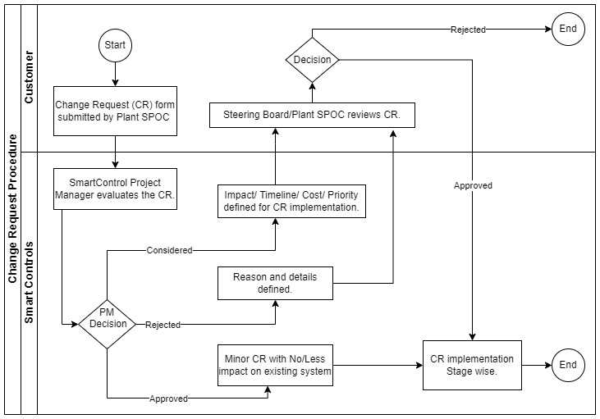
Any deviation requested in this proposal OR during implementation OR post implementation phase in project will follow the below mentioned procedure. The standard change process can be graphically represented as follows:

This change process covers all major/minor changes. All change orders are submitted by the project management and quantified with respect to budget and time.
Both project managers must approve the change before the described activity may be performed. If no agreement between the project managers can be achieved, the change is not accepted. Each project manager can invoke the Steering Board for further decision.
Should any assumption set out or referred to in the proposal prove to be invalid or should fail to carry out any of your obligations under the proposal, SmartControls will be entitled to equitable adjustments to the Services and to charge customer on a time and materials basis using SmartControls standard rates in effect from time to time for any resulting additional work or waiting time.

Change Request Implementation Stages:

Change in Scope Of Service:
Stages | Responsible | Dependency | Action
Change Request | Customer | CR Approval. | Customer to document the required change in detail and provide all related master data and prerequisites.
Solutioning | Smart Controls | Customer to provide complete requirement details and all related prerequisites. | Smart Controls to perform impact analysis, code analysis and design the solution.  The solution to be discussed and mutually agreed with Customer.
Building | Smart Controls | Customer to provide the acceptance criteria for the change. | Smart Controls to build the solution and preform unit testing and check acceptance criteria shared by Customer.
UAT | Customer | Smart Controls to deploy the solution on UAT Server. | Customer to test the solution in UAT server, perform impact and risk analysis and provide acceptance.
PROD | Smart Controls | Customer to provide the UAT acceptance. | Smart Controls to deploy the solution in PROD Server.
PROD | Smart Controls | Smart Controls to complete deployment. | Customer performs the acceptance testing in PROD Server.

Change in Scope Of Supply:
Stages | Responsible | Dependency | Action
Change Request | Customer | CR Approval. | Customer to document the required change in detail and provide related hardware specification details.
Solutioning | Smart Controls | Customer to provide complete requirement details and all related prerequisites. | Smart Controls to perform impact analysis and redesign the solution if needed.  The solution/change/impact to be discussed and mutually agreed with Customer.
Procurement & Readiness | Smart Controls | SmartControls and Customer to mutually agree to the change impact. | Smart Controls to procure the material as per CR and preform the required configurations on the hardware as per mutually agreed scope of work for the hardware.
UAT | Customer | Smart Controls to deploy the hardware on UAT Server. | Customer to test the hardware in UAT server and provide acceptance.
PROD | Smart Controls | Customer to provide the UAT acceptance. | Smart Controls to commission the hardware in PROD Server and performs the final acceptance testing.

Acceptance Procedures

Notification of Deliverable Available Date
The approval of documents is given in writing; for other delivery units (e.g., system and training) an approval report is prepared. Acceptance will be confirmed in writing. The same process will be applicable for each deliverable of each milestone. Smart Controls is responsible to give Customer notification of the date when the deliverable as listed in project deliverables section will be available for acceptance by the Customer.

User Acceptance Tests
For the description of test cases, a form will be provided which is commonly agreed by the project manager from Smart Controls and the customer will be used.

Inspection and Acceptance of Deliverables by Customer
Customer will notify Smart Controls in writing within five (5) working days following receipt of any milestone related deliverable for which Smart Controls has responsibility for delivery, if the deliverable fails to meet the acceptance criteria (if any) set out above. This notice shall state in reasonable detail and in a consolidated manner the reasons for a deliverable failing to meet such criteria.
Acceptance by the Customer shall not be unreasonably withheld. The passage of five (5) working days without notice of non-acceptance following delivery to Customer or the productive use by Customer of such deliverable shall constitute acceptance by the Customer.
If the notice of non-acceptance is not sufficiently detailed to allow Smart Controls to determine why such deliverable is unacceptable, Smart Controls may request in writing that the Customer provides sufficient additional information. The passage of five (5) working days from the date of such request without the provision of such additional information shall constitute acceptance of such deliverable by the Customer.
Smart Controls shall either rework such deliverable within fifteen (15) days after receipt of sufficient notice or present the Customer with a plan to rework the deliverable within a period of time that is reasonable under the circumstances.
Where the Scope of work does not set out acceptance criteria for any deliverable for which Smart Controls has responsibility for delivery, the deliverable will be deemed accepted on delivery to the Customer.
The project is completed if all deliverables as described are delivered to the Customer and accepted by the Customer via a formal Acceptance Document/email.

Commercial

Price Schedule
Price Summary
Total Implementation Price
Total Implementation Price in words
Note: Any changes in this proposal shall require re assessment of price.

Terms Of Payment
Scope of Services:
MS No | Milestone Name | Payment Value | Deliverables
1 | Business Requirement Document | 20% | BRD
2 | Functional Design Specifications | 20% | FDS
3 | UAT – Common Module (Item Management) | 10%
4 | UAT – RMS (Booking & Issue) | 10%
5 | UAT – Mixer (Carbon, Silica & Oil) | 10%
6 | UAT – Mixer (Auto Chemical, Bale Cutter) | 10%
7 | UAT – Mixer (Feeding & Booking) | 10%
12 | Overall Go Live | 10%

Scope of Supply:
MS No | Milestone Name | Payment Value | Deliverables
1 | PO Acceptance & Advance | 30% | PO acceptance and submission of advance request.
2 | Material Invoice & Dispatch | 70% | Submission of Invoices & dispatch documents, within 30days from the date of Invoice.
Note: In case of part dispatches, pro rata payment shall be made for respective invoice.

Ownership of Deliverables
1. Pre-existing Software and Technology. Each party will retain all rights in any software, ideas, concepts, know-how, development tools, techniques or any other proprietary material or information that it owned or developed prior to the inception of a professional services project or acquired or developed thereafter without reference to or use of the intellectual property of the other party.
2. Third Party Software and Technology. All software and technology that is licensed by a party from a third-party vendor will be and remain the property of such vendor.
3. Deliverables Based on Smart Controls Software and Technology. Subject to any third-party rights or restrictions, Smart Controls will own all intellectual property rights in or related to all deliverables that are developed and delivered by Smart Controls, provided that they consist of pre-existing Smart Controls software or Smart Controls software development tools, modifications thereto developed as part of the Services, or works derived from pre-existing Smart Controls software or Smart Controls Tools developed as part of the Services.
4. Deliverables Based on Customer’s Software and Technology. Subject to any third-party rights or restrictions, Customer shall own all intellectual property rights in or related to any deliverables that do not constitute pre-existing Smart Controls software, Smart Controls Tools, or modifications thereto or works derived therefrom, that are developed as part of the Services.
5. The Services provided hereunder shall not constitute “works made for hire” under any applicable copyright laws. Ownership of work in progress under a Scope of Work shall remain with Smart Controls until such time as title to a Deliverable transfer, if at all, in accordance with the signed Agreement.
7. No License to Intellectual Property of the Other Party: No licenses will be deemed to have been granted by either party to any of its patents, copyrights, trade secrets or other intellectual property except as otherwise expressly provided in the Agreement. Smart Controls will be free to use the ideas, concepts, methodologies, processes and know-how that are developed or created in the course of performing the Services provided that Smart Controls does not use, or make reference to, the intellectual property or proprietary information of Customer.

Terms and Conditions

This document reflects Smart Controls understanding of the business needs and project requirements and was prepared based on the information available at that point in time. Any changes to these needs or requirements may require changes to technical and commercial proposal. The information in this proposal may not be disclosed outside of Customer and may not be duplicated, used, or disclosed in whole or in part for any purpose other than to evaluate the proposal. Smart Controls retains ownership of this proposal.
GENERAL
- Each party acknowledges that this Contract is the complete and exclusive statement of the agreement between the parties, which supersedes and merges all prior proposals, understandings, and all other agreement, oral and written, between the parties relating to this Contract. This Contract may not be modified or altered except by a written instrument duly executed by both parties.
- If any provision of this Contract shall be held to be invalid, illegal, or unenforceable, the validity, legality and enforceability of the remaining provisions shall in no way be affected or impaired thereby.
- The CUSTOMER shall not subcontract, assign, or transfer its rights, duties or obligations under this Contract to any person or entity, in whole or in part, without the prior written consent of the Smart Controls.
PRICE BASIS

VALIDITY OF OFFER
Offered prices are valid for order placement within 30days from the date of this offer.
PACKING
NA.
TRANSIT INSURANCE
Required
TAX & DUTIES
SGST/CGST/IGST @ EXTRA at actuals as applicable at the time of transactions.
Offered rates/prices are excluding charges for taxes, fees, duties, levies, tariffs charged on the importation of goods and or services or other government charges related to offering. Buyer will pay these amounts or reimburse Smart Controls. If Buyer claims a tax or other exemption or direct payment permit, Buyer will provide a valid exemption certificate or permit and indemnify, defend and hold Smart harmless from any taxes, costs and penalties arising from same. Increases, changes (including in application), adjustments or surcharges which may be incurred are to Buyer’s account.

TERMS OF PAYMENT
The billing shall be made as per Terms of Payment mentioned under Clause 7.2.
Payment shall be made within 45 days from the date of Invoice. Any deductions on account of TDS or Withholding Taxes as per govt. regulations while releasing our payments shall be accepted with a declaration that for deducted amount you shall provide us TDS certificate to us for deducted amount.
LATE PAYMENTS
Late payments shall bear interest at an annual percentage rate of eighteen percent (18%) for the delayed payments.
DISPATCH/DELIVERIES
The delivery of scope of supply and service shall be 48 weeks from the date of advance.

ORDER AMENDMENTS
Any change in Services, Supply, & or change in scope of other terms shall entail revision of deliveries & prices.

WARRANTY
Smart Controls warrants that it will perform the Services in a professional manner. All supply materials offered by us under this offering are warranted against standard warranty.

FORCE MAJEURE APPLICABLE
Seller will not be liable for failure to perform any obligation or delay in performance resulting from any cause beyond the reasonable control of Seller or its suppliers or from any act of God; Pandemic; act of civil or military authority; act or war whether declared or undeclared; act (including delay, failure to act, or priority) of any governmental authority, purchaser, purchaser’s customer or other contractors; or civil disturbance; insurrection or riot; sabotage; fire; inclement weather conditions; earthquake; flood; strike; work stoppage or other labour difficulty; embargo; fuel or energy shortage; wreck; major equipment or product breakdown; delay or accident in shipping or transportation; or failure or delay beyond its reasonable control in obtaining necessary manufacturing facilities, labour or materials from its usual sources.
In the event of delay in performance excusable under this Article, the time for performance of the work will be extended by a period of time reasonably necessary to overcome the effect of the delay.
LIMITATION OF LIABILITY
In no event Smart Controls shall be liable for any consequential loss or damage arising out of or connected with this Purchase Order in any way whatsoever.
ARBITRATION
If a dispute, controversy or claim arises out of or relates to this contract, or breach, termination or invalidity thereof, and if such dispute, controversy or claim cannot be settled and resolved through negotiation, then the parties agree first to try in good faith to settle such dispute, controversy or claim through conciliation at the Gwalior Arbitration Centre.
Any issue or claim not resolved by conciliation shall be referred to and finally resolved by arbitration in Gwalior in accordance with the Gwalior Arbitration Centre Rules for the time being in force which Rules are deemed to be incorporated by reference into this clause.
ORDER PLACEMENT
The order should be in favour of “M/S Smart Controls India Ltd, Smart House, Telegraph Road, Besides VIP Circuit House, Morar, Gwalior, M.P. - 474006.”
CANCELLATION
This Contract is non-cancellable, under no circumstances the PO is liable for cancellation. If the purchaser cancels the PO, Advances/milestone payments shall be forfeited.

PROVIDER | SMART CONTROLS | PROVIDER | SMART CONTROLS
Name: | Bibhuti Dash | Name: | Md Tarique Ahmad
Title: | Chief Operating Officer | Title: | Head of Sales, Digital Manufacturing
Signature: |  | Signature:
Date:

